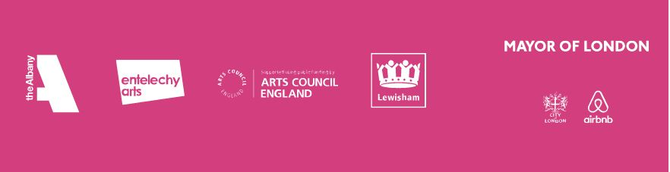

Age Against the Machine
The Albany and Entelechy Arts in partnership with London Borough of Lewisham

If you need a larger print version of this form then please contact us

Age Against the Machine
VOLUNTEER ROLE TITLE: Festival Volunteer
PERSONAL DETAILS
First Name |  |  | Title
Surname
Address

Postcode

Tel: |  | Mobile:
Email:
Emergency contact name:
Emergency contact number:
Why are you interested in volunteering with us?

Tell us about your experience of volunteering, if you have any.

Do you have experience of supporting events? If so please give more information.

What other skills and experience would you be able contribute to this role?

What do you think some of the concerns would be for an isolated older person attending a large public event?

What would you like to get out of this role?

Please cross your availability (a minimum of three events):

 | Fri | Sat | Sun
 | 13-Sep | 14-Sep | 15-Sep
Am
Pm
eve
 | Mon | Tue | Wed | Thu | Fri | Sat | Sun
 | 23-Sep | 24-Sep | 25-Sep | 26-Sep | 27-Sep | 28-Sep | 29-Sep
am
pm
eve
 | Mon | Tue | Wed | Thu | Fri | Sat | Sun
 | 16-Sep | 17-Sep | 18-Sep | 19-Sep | 20-Sep | 21-Sep | 22-Sep
am
pm
eve
 | Mon | Tue | Wed | Thu | Fri | Sat | Sun
 | 30-Sep | 01-Oct | 02-Oct | 03-Oct | 04-Oct | 05-Oct | 06-Oct
am
pm
eve

Please circle the training date you’d be available for:

Friday the 6th of September, 2pm-4.30pm, The Albany, Red Room.

Monday the 9th of September, 6.30pm-9pm, The Albany, Red Room.

Are there any events you’d like to volunteer at? We will do our best to match you up to events you are interested in.

We will be providing T-shirts for Festival volunteers. Could you please circle the size you’d like:

S M L XL

So we can best support you whilst volunteering with us please could you share any access requirements or medical conditions you want us to be aware of:

Entelechy Arts are committed to ensuring that your privacy is protected. Your details will be stored securely on and offline and will never be shared.

See online privacy policy also: http://entelechyarts.org/privacy-notice/

Please return this form to:

Sarah Jarman
Volunteer coordinator

Email: sarah.jarman@entelechyarts.org

By Post to:
The Albany
Douglas Way
London SE8 4AG

More information: 020 8694 9007

